**Case Study: Scheduling via PDM**

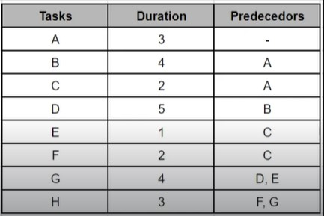

**B** **D**

**A** **G** **H**

**C** **E**

**F**

|  |  |  |  |
| --- | --- | --- | --- |
|  | AN |  |  |
|  | DU |  |  |

AN = Activity Name

DU = Duration

|  |  |  |  |
| --- | --- | --- | --- |
|  | B |  |  |
|  | 4 |  |  |

|  |  |  |  |
| --- | --- | --- | --- |
|  | D |  |  |
|  | 5 |  |  |

|  |  |  |  |
| --- | --- | --- | --- |
|  | G |  |  |
|  | 4 |  |  |

|  |  |  |  |
| --- | --- | --- | --- |
|  | E |  |  |
|  | 1 |  |  |

|  |  |  |  |
| --- | --- | --- | --- |
|  | A |  |  |
|  | 5 |  |  |

|  |  |  |  |
| --- | --- | --- | --- |
|  | C |  |  |
|  | 2 |  |  |

|  |  |  |  |
| --- | --- | --- | --- |
|  | H |  |  |
|  | 3 |  |  |

|  |  |  |  |
| --- | --- | --- | --- |
|  | F |  |  |
|  | 2 |  |  |